CS3650 Assignment 3

Josh Brenneman

1. I created a new folder called initrepo and inside typed git init. I initialized the folder.

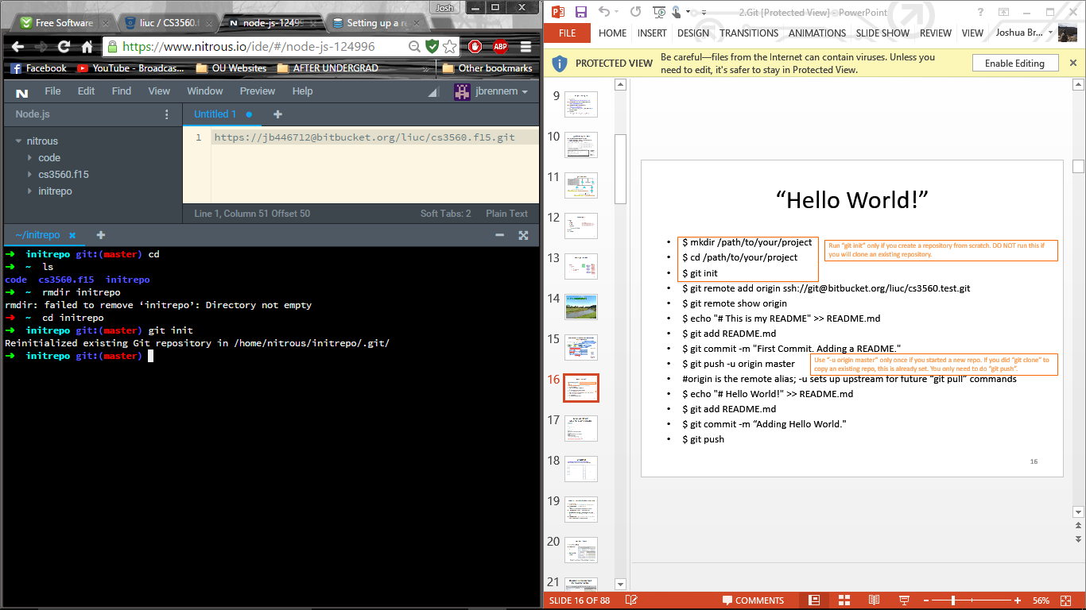

1. Then I used mkdir in order to make three subfolders: folder1, folder2, folder3.

In each folder I made two files: file1,…, file6

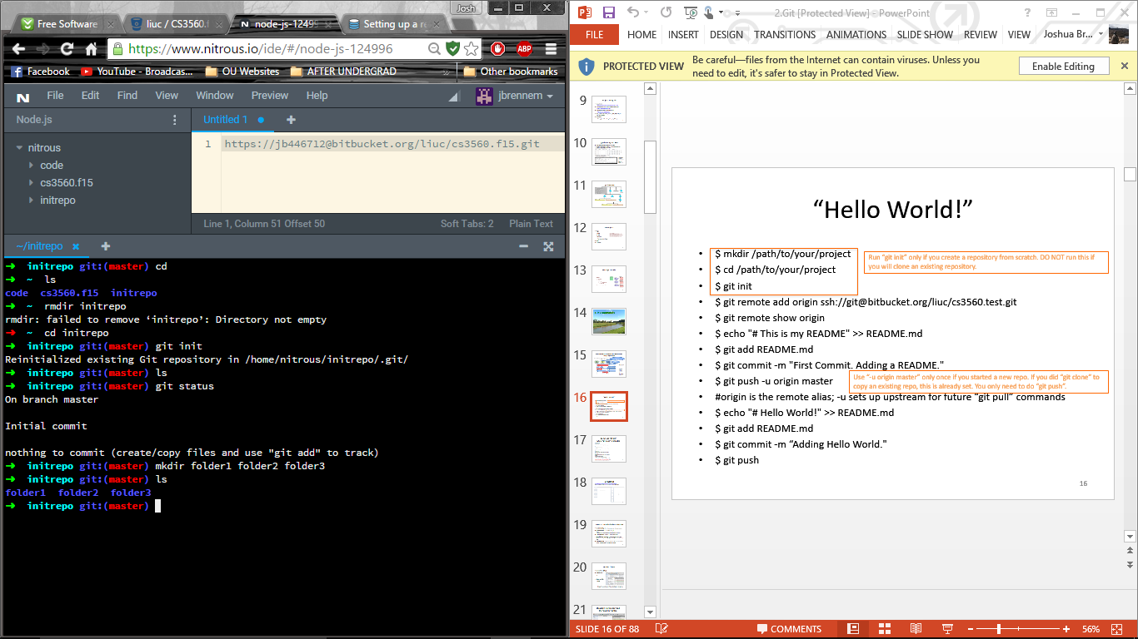

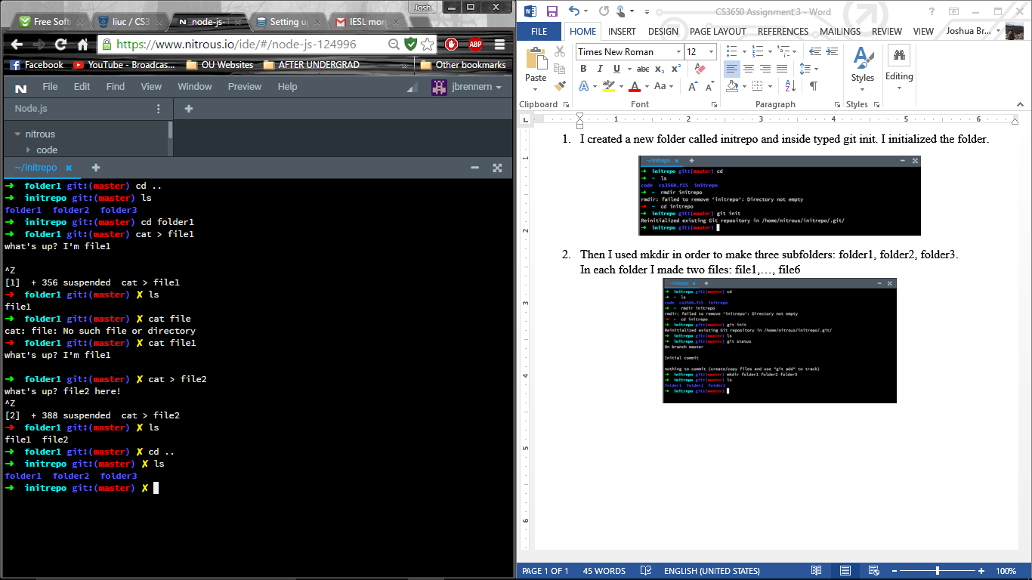

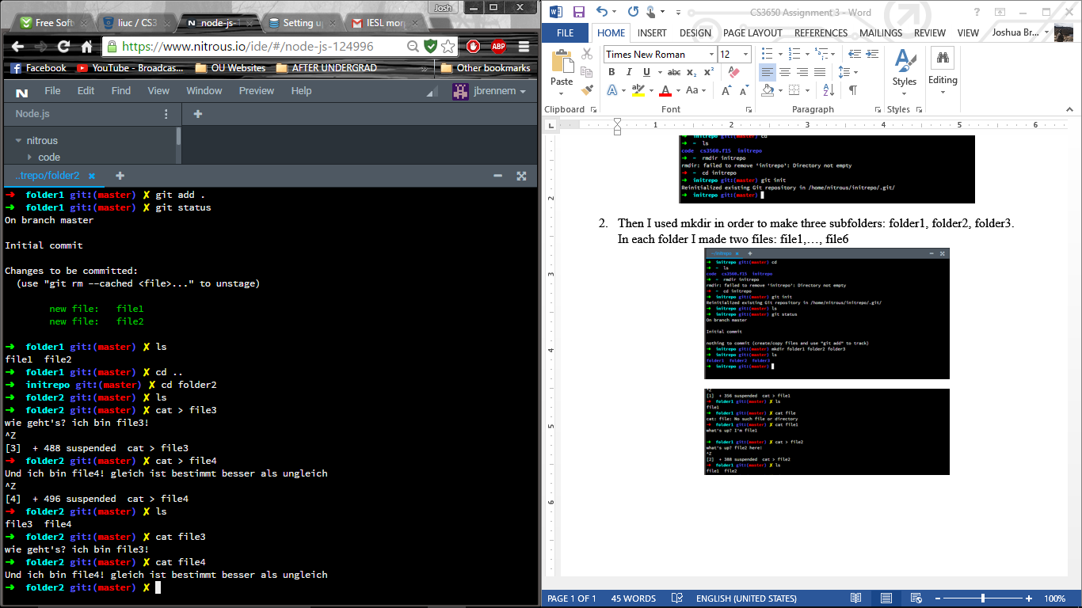

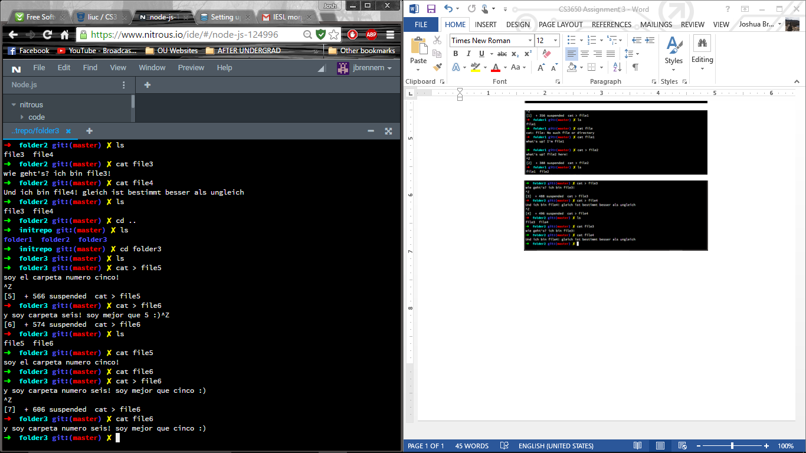

1. In my root folder “initrepo”, I created the file README.md

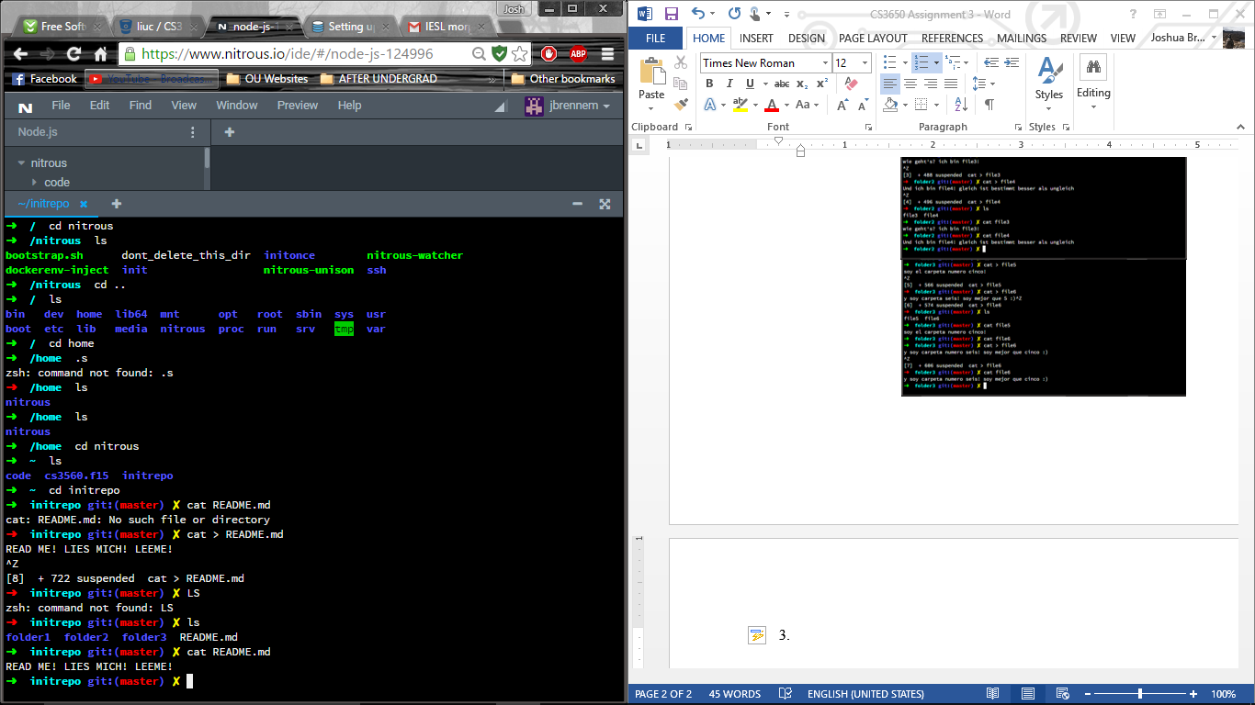

1. I committed all the files and folders and then created a tag named ‘v1’.

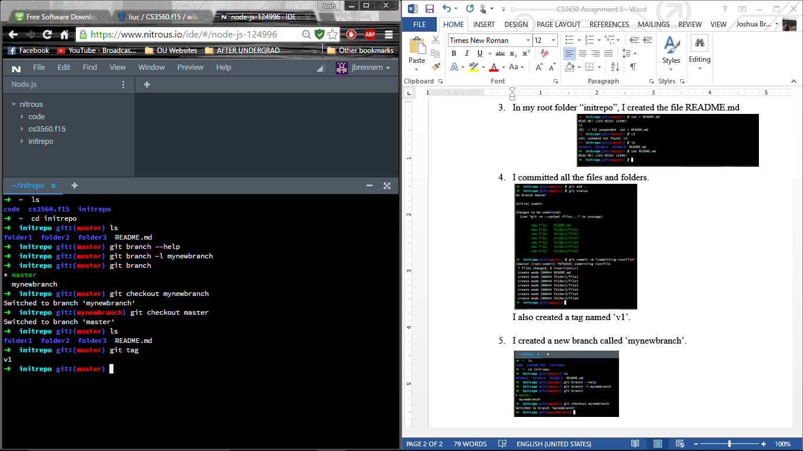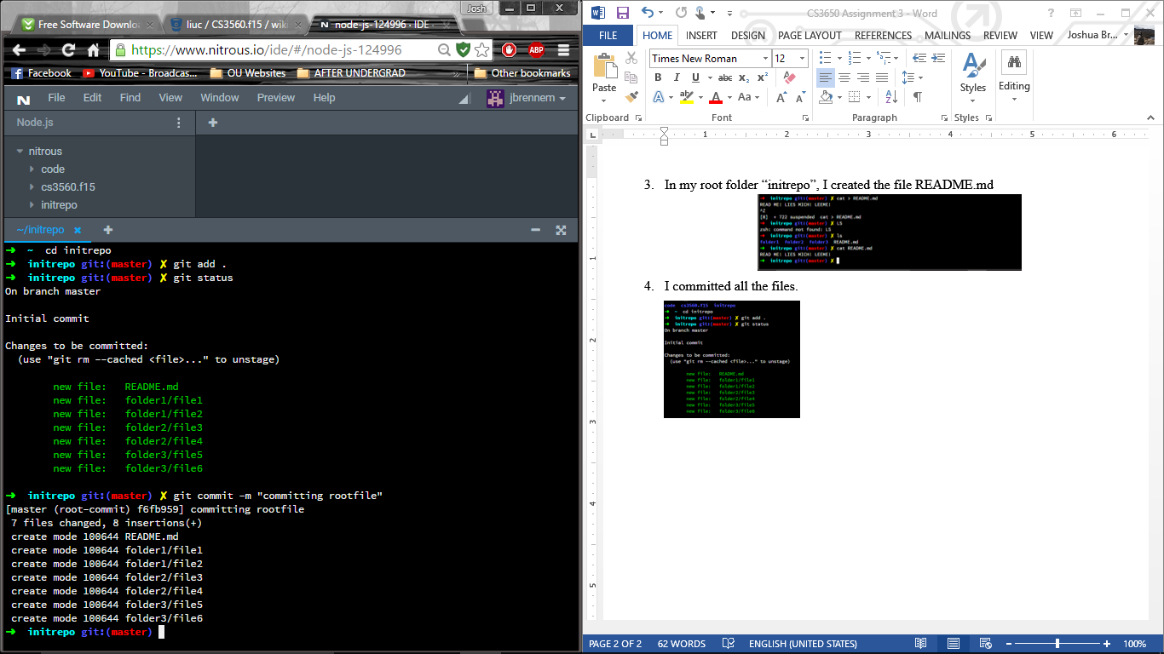

1. 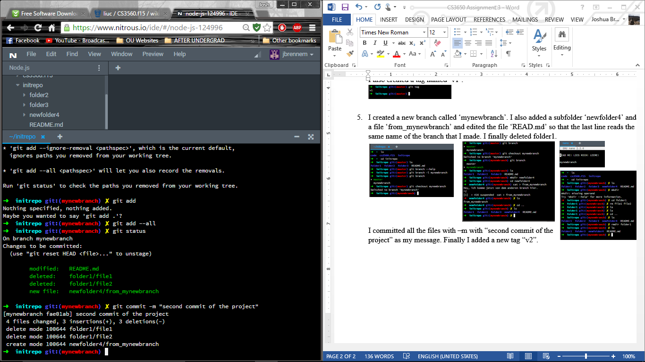I created a new branch called ‘mynewbranch’. I also added a subfolder ‘newfolder4’ and a file ‘from_mynewbranch’ and edited the file ‘READ.md’ so that the last line reads the same name of the branch that I made. I finally deleted folder1. I committed all the files with –m with “second commit of the project” as my message. Finally I added a new tag “v2”.

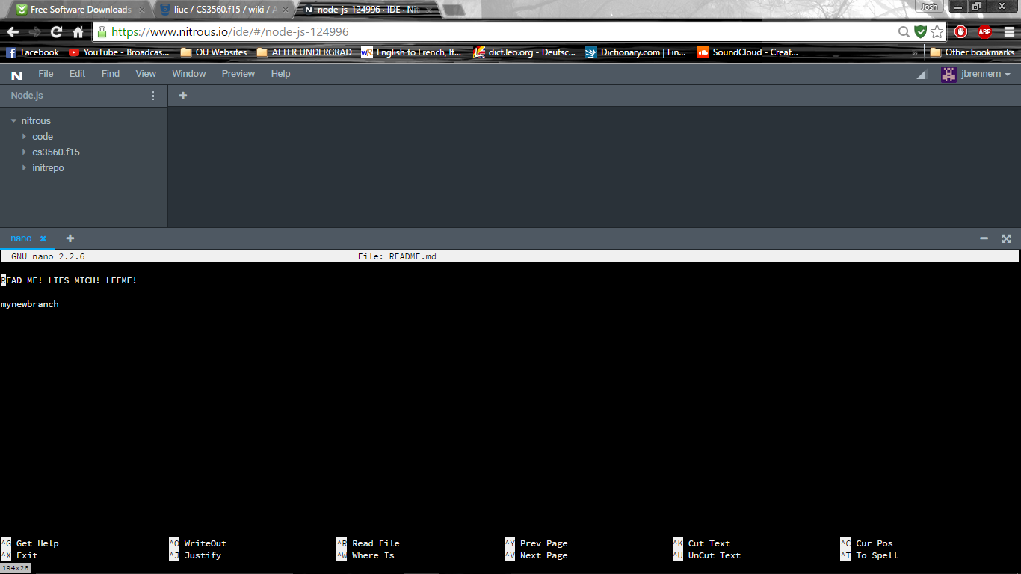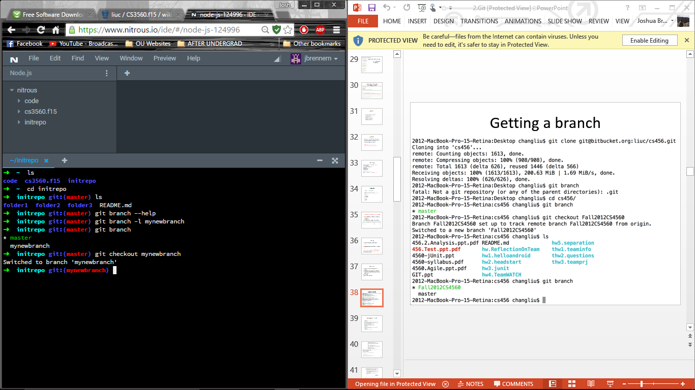

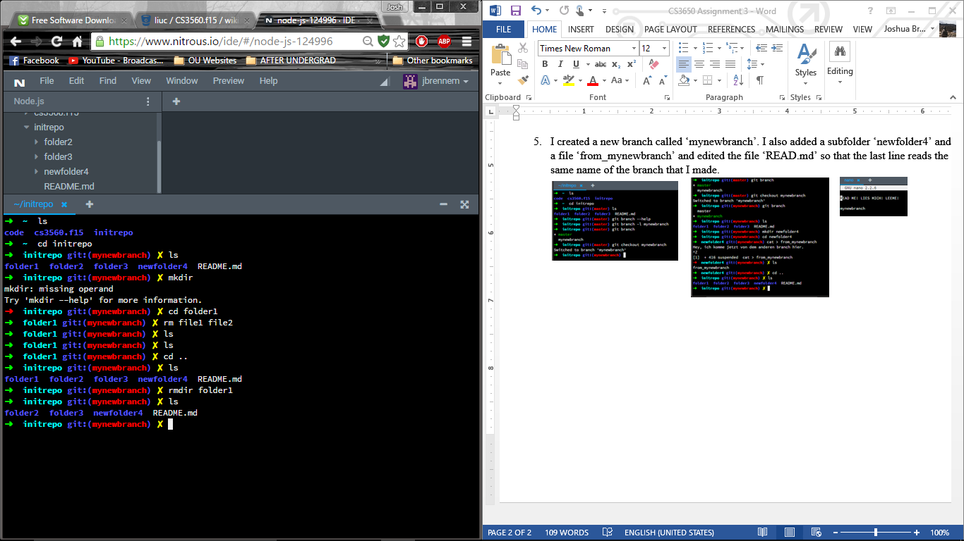

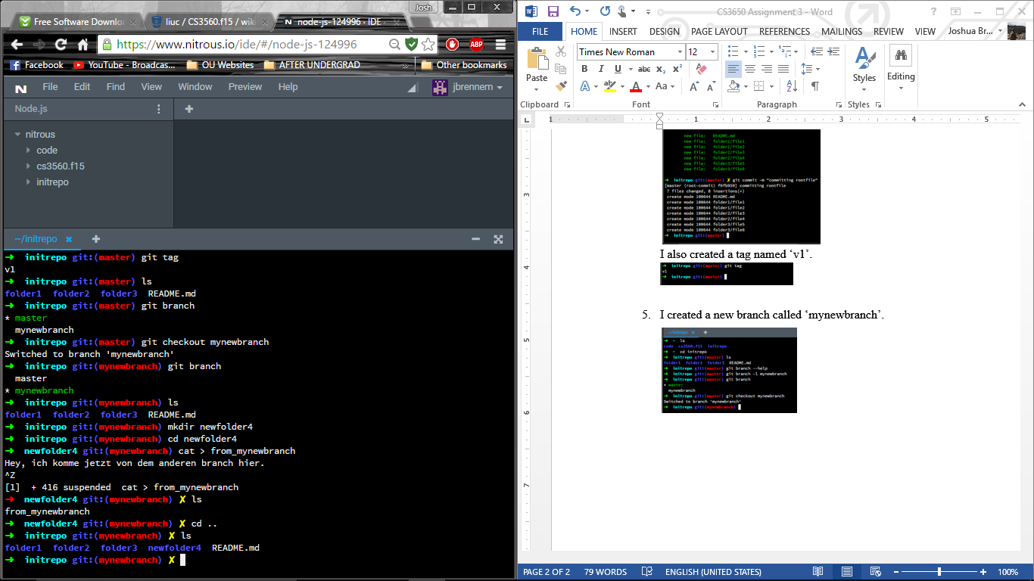

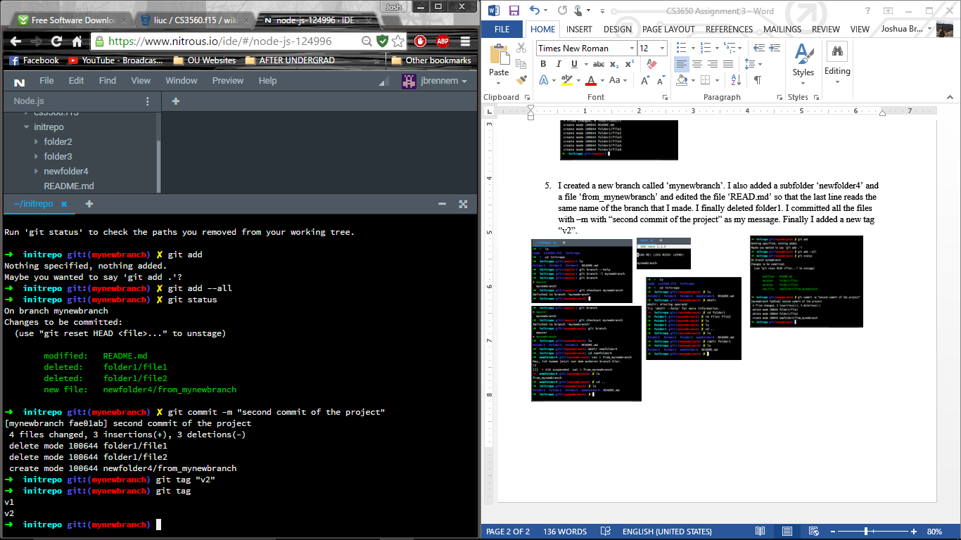

1. I switched to the master branch. I added some commentary in German to README.md using nano, committed the file and added tag “v1.1” with the command git tag “v1.1”

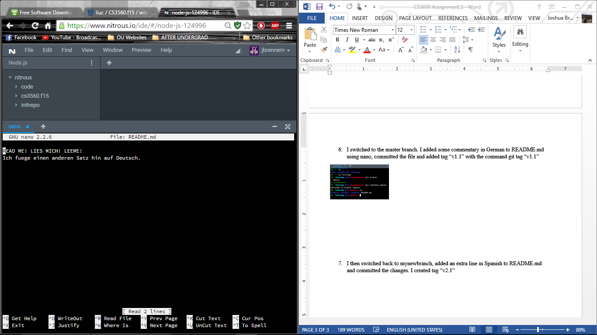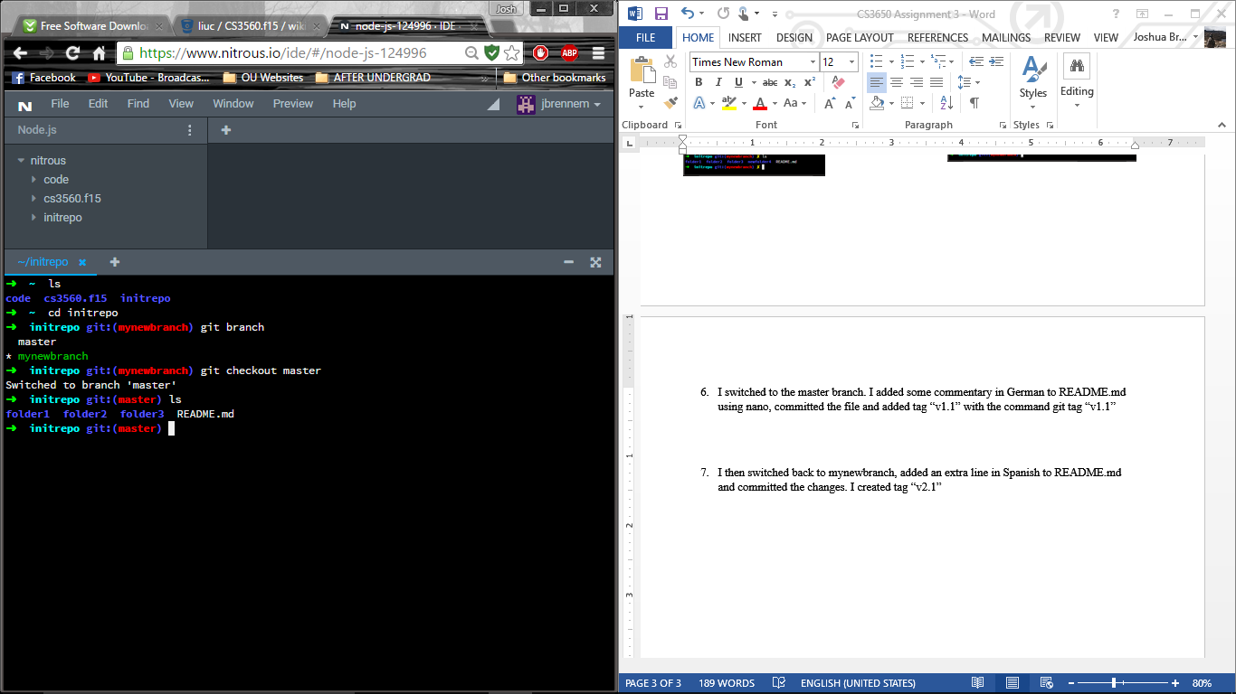

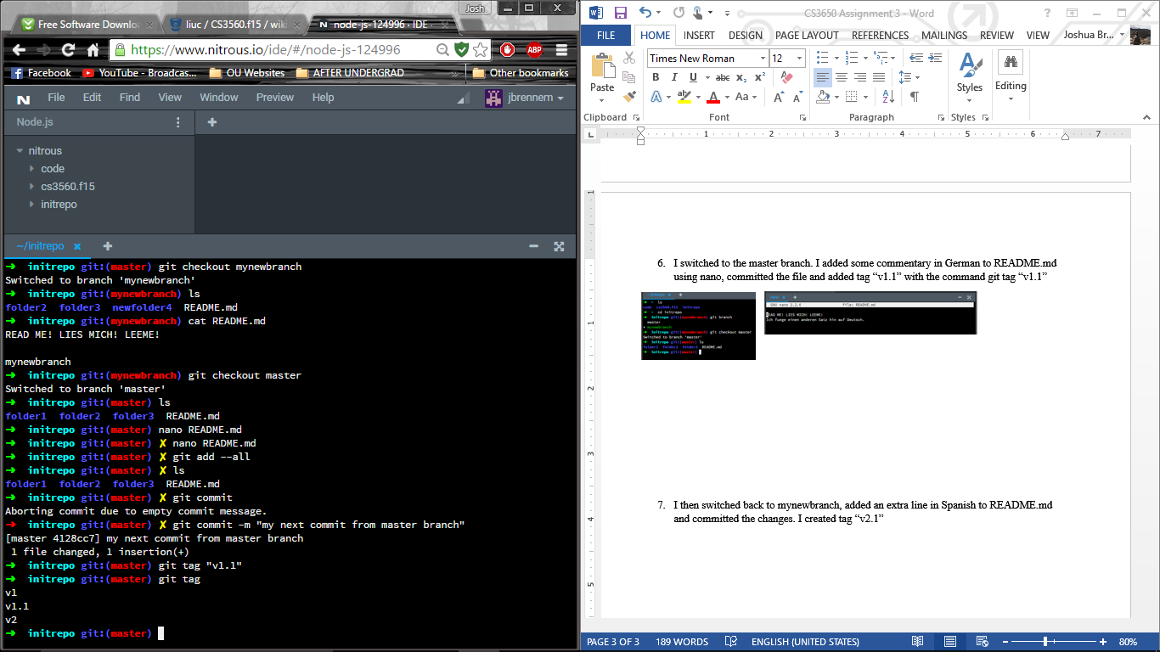

1. 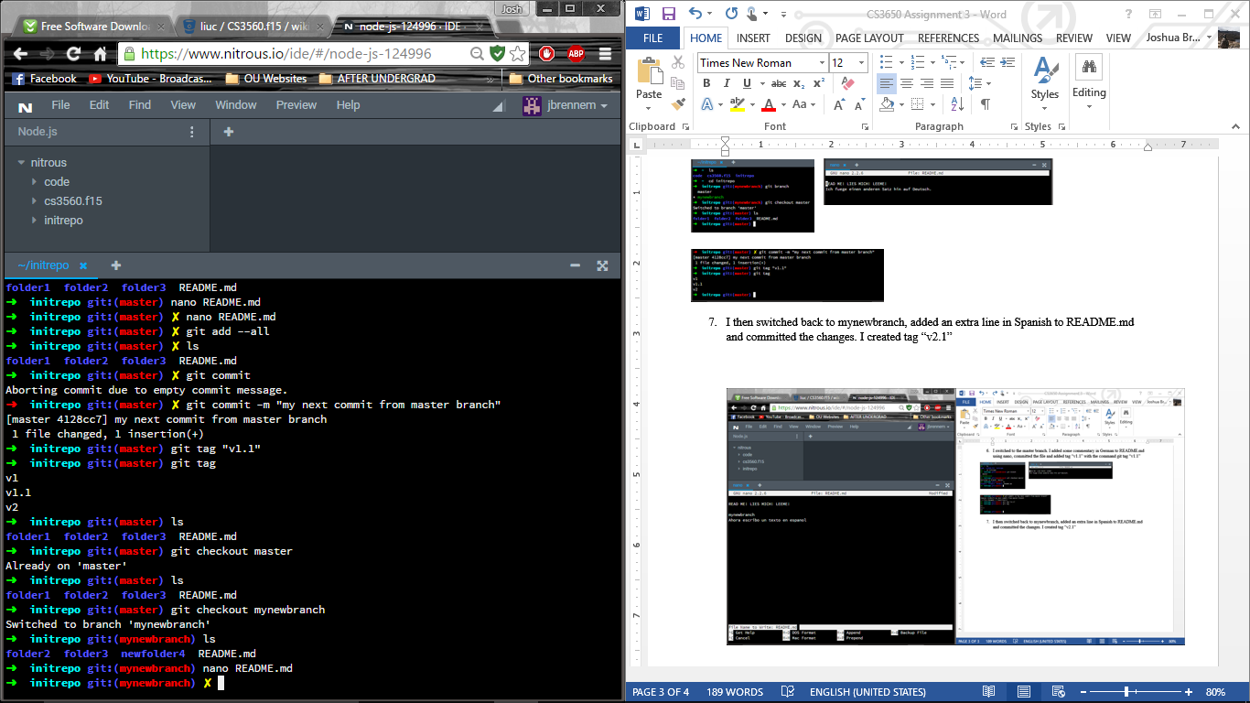I then switched back to mynewbranch, added an extra line in Spanish to README.md and committed the changes. I created tag “v2.1”

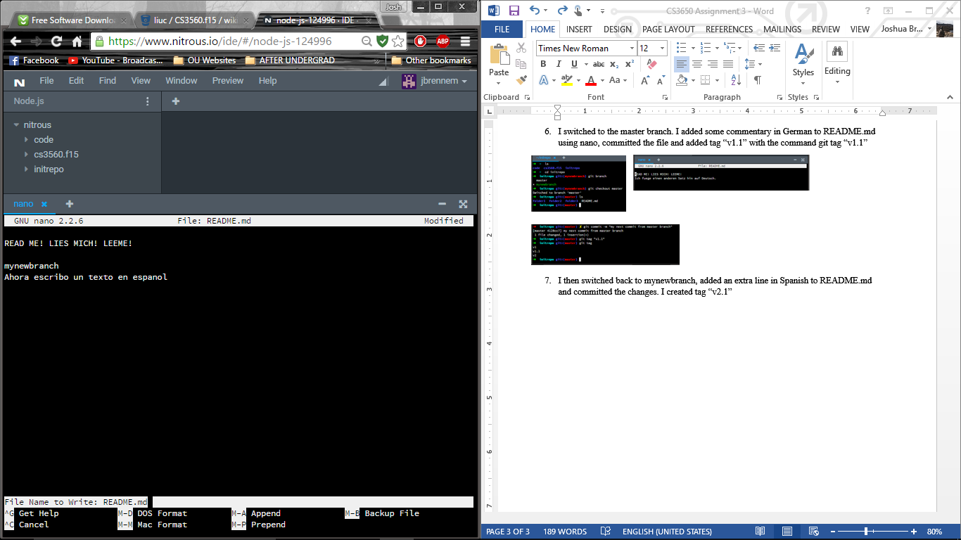

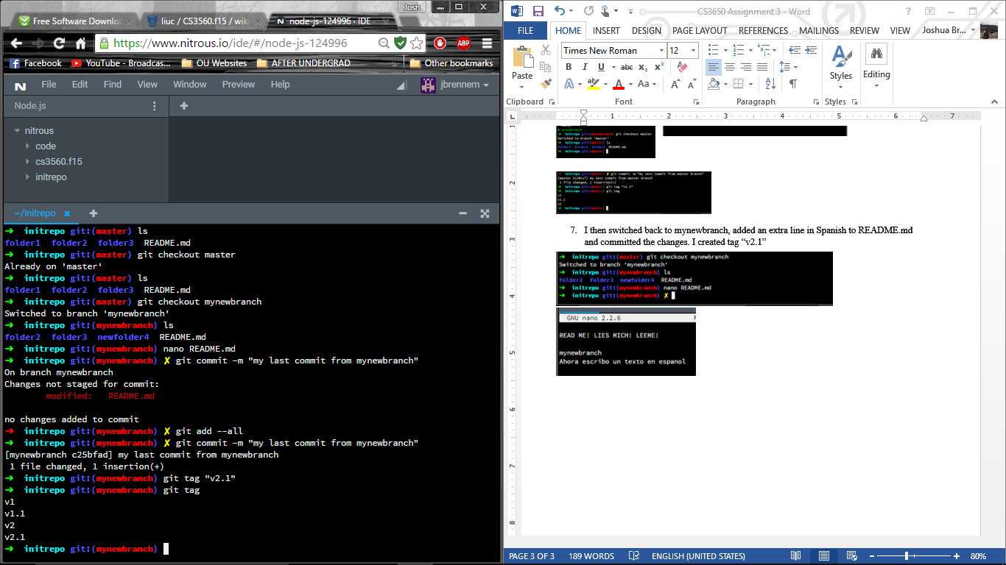

1. I downloaded Source Tree and connected to bitbucket.

